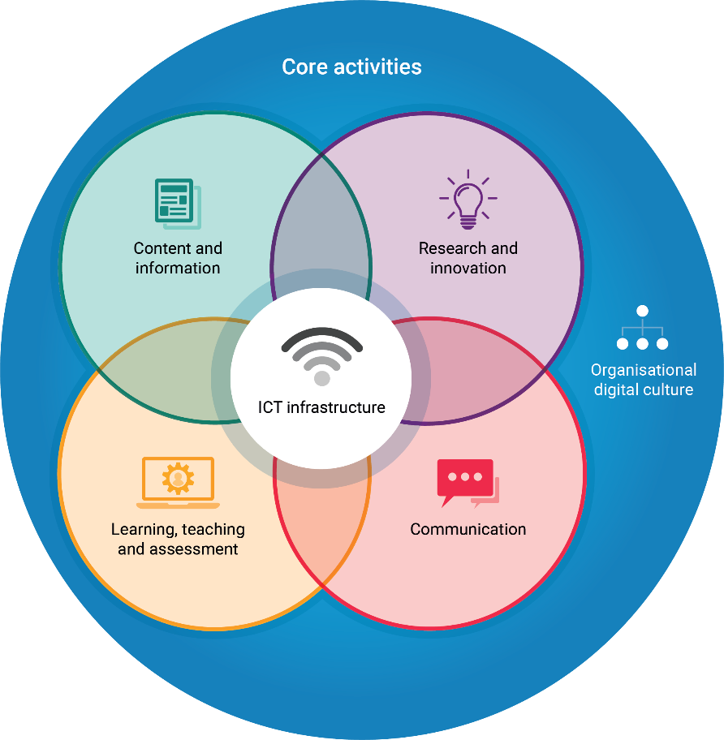
Jisc organisational digital capabilities maturity model

This maturity model has been developed to provide an ‘at a glance’ tool to support universities and colleges consider their digital capability at an organisational level. It can be used to start conversations, identify starting points, support reflection, and contribute to improvements. It looks beyond the capabilities of individuals and acknowledges that digital capabilities impact on, and are relevant to, all areas of university and college business (academic and non-academic).

The model is based on the six elements of organisational digital capability identified in our organisational framework and reflects and complements our digital capability framework for individuals. Find out more about these frameworks at https://digitalcapability.jisc.ac.uk/what-is-digital-capability/. It is intended that the model will be used to support organisations using our building digital capability service.

Guidance points for using the maturity model
» Invite groups of stakeholders to discuss the principles and how they apply in your context to ensure you understand different stakeholder perspectives  » Decide where you should aim to be on our spectrum of maturity bearing in mind that not all organisations will or should be aiming to achieve the enhanced level  » Think about what evidence might show that you are applying each principle. Remember the indicators we suggest are purely a guide. You will be able to think of many other indicators that fit your context better so adapt this template to suit your situation  » Use our quick self-assessment template to jot down your thoughts and our radar diagram template to sum up graphically | » It is likely you will find that practice is more advanced in some parts of your organisation than in others. Note any significant differences rather than simply averaging out. You may want to do a series of radar diagrams to highlight the main differences graphically  » Use the model to start a dialogue. Identify and celebrate good practice, identify what can easily be changed and set longer-term goals for progress. Encourage key stakeholders to engage with what’s possible and work towards your shared vision of what a digitally capable organisation means to you  If you have any questions or feedback about using this maturity model, please contact us at help@jisc.ac.uk with ‘digital capability’ in the email subject line
Organisational digital culture
Good practice principle: the organisation embraces digital technologies as a key tenet of business success

Emerging | Established | Enhanced
- The organisation understands how digital technologies can benefit it and  - Stakeholders from all areas are involved in developing a shared, understood language around ‘digital’ and the digital vision | - The digital vision is being contextualised by different parts of the organisation | - There is a shared, contextualised and nuanced understanding about digital as a result of many staff and students engaging with the agenda
- The organisation signals the importance of digital by a digital strategy that covers learning and teaching, research, administration and infrastructure | - Digital capability is no longer new or a project: it is embedded into all core strategies with delivery overseen by a cross-institutional stakeholder group  - Digital wellbeing is embedded in existing policies and strategies, particularly those on accessibility and inclusion | - Managing digital capability and wellbeing underpins the organisational governance: no major decision is signed off unless digital options, infrastructure and skills have been considered
- Digital champions have senior level sponsorship even if not all senior managers feel confident to lead by example | - Digital leadership (by example) and capacity building exist at senior level in most core business areas | - Digital leadership and capacity building exist at senior level in all business areas (including HR, research, student support, estates and quality)
- The organisation has digital champions in its core business areas and amongst its student body | - There is support for projects involving digital staff and student champions | - Enabling partnerships exist between staff and students to take forward the digital agenda
- The organisation has identified some targets for digital development and a formal monitoring process | - The organisation has identified key performance indicators for digital and a formal monitoring and review process  - Staff and students have access to online data and tailored dashboards to help them monitor and achieve their goals | - Data-informed decision-making and structured benefits realisation exists across areas from smart buildings to decisions about curriculum and research
- The organisation is starting to offer online alternatives to manual business processes | - Business processes are automated if possible | - Business processes are designed with a critically-aware digital first philosophy

Organisational digital culture
Good practice principle: the organisation develops the digital capabilities of its students and staff

Emerging | Established | Enhanced
- The organisation has done some assessment of staff and student digital capabilities to help plan | - The organisation has done large-scale assessment of staff and student digital capabilities and has tailored action plans with evaluation criteria | - All business units have a view of current and desired staff and student digital capabilities, localised action plans and monitoring
- The organisation has defined some threshold standards for staff and student digital capabilities but these are not yet embedded in recruitment and review processes | - The organisation has role profiles defining digital capabilities for many roles and levels with a structured development lifecycle  - Digital capabilities form part of staff appraisal and tailored staff development is on offer  - Managing digital capabilities is becoming embedded into staff and student life-cycle management via recruitment, induction, training and review | - The organisation has mapped all ‘touchpoints’ for staff and students when digital capabilities should be addressed  - Digital capabilities are embedded in recruitment and selection, induction, appraisal and reward procedures for all staff
- Generic staff development on a range of digital topics is offered on-demand | - Staff are given time and management support to develop digital skills and reflect on their practice | - The organisational culture encourages students and staff reflection on skills and empowers responsibility for personal development
- Generic training in core technologies and digital skills is offered at student/researcher induction and thereafter at point of need | - Students and researchers experience contextualised use of technology and build digital skills through project work and assessment | - Development of appropriate digital skills is fully embedded into curriculum/research design and accredited by inclusion in learner/graduate attributes, research mentoring and summative assessment
- Staff and students are offered generic support and guidance in staying safe online.  - The organisation engages with staff and students to find out how digital activities, tools and working practices affect their wellbeing | - Staff and students are offered contextualised support and guidance in managing their digital identity and well-being | - Digital identity and well-being is part of personal development planning for all staff and students and built into processes for managing this

Learning, teaching and assessment
Good practice principle: learning, teaching and assessment practices motivate and empower students and help them develop as digitally- capable, independent learners

Emerging | Established | Enhanced
- Learning activities and resources are considered as part of regular course/module review and digital resources and activities are included to help meet learning outcomes where appropriate | - All courses and modules involve an appropriate blend of digital and non-digital learning resources and activities | - Learning activities and support services are technically, physically and intellectually accessible and inclusive for all regardless of cultural background, first language, physical impairment or specific learning difficulties  - The organisation collects and analyses data on how different types of learning activity may impact student and achievement
- Course and module design is informed by evidence about student digital capabilities | - Students are active participants in decisions relating to course and module redesign and the use of digital technologies | - The organisation participates in education research and professional networks relating to technology enhanced learning
- The organisation is exploring the use of learning analytics | - The organisation uses data and analytics to improve learning and the student experience | - The organisation is using analytics about learning activities and learning design to improve its curriculum
- Teachers are able to adapt course delivery to make best use of digital tools and activities for a particular cohort | - Students have a lot of freedom in their choice of tools and media for learning activities and assessed work | - The organisation acts on student feedback about digital learning practices
- The organisation engages with students to find out how digital learning activities, tools and content affect their wellbeing | - Staff designing learning and those in support services are aware of ways in which digital activities, tools and content can positively or negatively affect wellbeing | - The organisation gathers data on digital wellbeing to inform planning and responses to problems

Learning, teaching and assessment
Good practice principle: learning, teaching and assessment practices use digital technologies to help demonstrate achievement and prepare learners for future success

Emerging | Established | Enhanced
- Some course teams and student representatives champion the inclusion of digital capabilities in learning outcomes but this is not yet embedded practice across the curriculum | - Organisational quality assurance processes embed development of digital capabilities into the curriculum | - Innovative use of digital technologies is a key differentiator between some of your organisation’s courses and your competitors’
- Digital capabilities are viewed as important learner/graduate outcomes and employability skills | - The inclusion of digital practices is an important aspect of building employability outcomes into the curriculum/research design  - Students/researchers gain experience in using up-to-date digital tools for their particular discipline/future profession and participate in digital communities of practice | - Digital capabilities are fully embedded into the employability agenda  - Digital tools, such as virtual environments and simulations, accelerate and enhance learning by creating authentic learning situations
- All students develop skills in using digital tools to manage their own time and productivity and for finding, evaluating creating and presenting information | - Students are supported to use digital tools and for reflection and recording achievement and self and peer review. Using these tools is part of formal assessment | - Student digital capability is recognised by academic credit and rewards such as open badges
- Assessment involves use of digital tools where this is a course requirement and some assessment administration is online | - A significant amount of assessment administration is online | - Assessment practice is characterised by digital assessment, marking and feedback enabling staff and students to engage in dialogue and to access all relevant information in one place

Research and innovation
Good practice principle: the organisation’s research is underpinned by digital capability

Emerging | Established | Enhanced
- Researchers are supported to find, evaluate, manage, curate, organise and share digital content for research and scholarship | - Researchers contribute to the development of new digitally-based methods, theories, research questions/areas or practices in their subject/discipline area and champion these approaches within their community | - Researchers are using digital tools and information to challenge traditional thinking and make advances across disciplines and at national/international level
- The research infrastructure aids secure and responsible collection, analysis and management of research data using digital methods | - The organisation adopts digital tools to help assess researcher needs | - Use of digital technologies and development of digital capabilities for research is a key differentiator marking out this organisation’s research outputs
- Organisational CPD includes training on the use of digital tools for research | - Researchers routinely use digital tools and can critically evaluate the most appropriate tools for their research | - Researchers experiment with, modify and develop new tools
- The institutional research strategy allows for investment in infrastructure and tools to enhance research output | - The organisation's research infrastructure can interoperate with external systems | - The infrastructure allows researchers to carry out all tasks related to research and research management in a way that appears seamless
- The organisation is implementing workflows for research information management (eg grant submissions, ethics, financial reporting) and, where possible, these are digitally based | - Most of the workflows for research information management are digital (eg grant submissions, approvals, reviews and management; ethics; financial reporting; internal reporting of research activity; etc) | - There is a digital ‘single source of truth’ around research activity (including outputs, grants, research students, research staff) which is easy to access/update/review by researchers, senior leaders and research support staff  - This ‘single source of truth’ is underpinned by use of identifiers and sector standards to ensure interoperability with funders’, publishers’ and open science platforms

Research and innovation
Good practice principle: the organisation’s research and scholarship exemplify how its digital capabilities support corporate social responsibility and responsible research practice

Emerging | Established | Enhanced
- Researchers behave safely and ethically in their management of research data and outputs and their engagement in digital research communities and with the wider public | - Use of digital tools and communications permits the creation of scholarly communities that support research-led teaching, promote good academic practice and engage a wider public in dialogue about the impact of research on the environment, society and culture | - Use of digital tools and communications positions the organisation as a global influencer in terms of open research, public engagement and knowledge exchange
- The organisation makes researchers aware of their responsibility to research integrity and reproducibility | - Researchers practice ensures their outputs fulfil requirements for research integrity and reproducibility  - The infrastructure supports Open and FAIR practice | - Researchers adopt open science principles (where appropriate), using institutionally supported open infrastructure
- The organisation has a clear policy for evaluation of research and researchers in place. Researchers can scrutinise the outcomes and correct mistakes | - The organisation has a policy for evaluation of research and demonstrates understanding of issues relating to research metrics (eg which metrics are used, how they are calculated, and consequences of choice of metrics providers) | - Good practice in research evaluation is recognised and rewarded  - Digital sources of data (arising from evaluation processes and research metrics) are fed back into strategy and policy at the individual, research group, departmental and organisational level

ICT infrastructure
Good practice principle: the organisation has a robust, secure and flexible digital infrastructure

Emerging | Established | Enhanced
- There is life-cycle management of infrastructure and applications and a developing IT architecture roadmap | - There is a well-managed IT architecture  - Centralised network management avoids local or ‘rogue’ IT applications meaning all IT systems comply with GDPR and security policies | - The organisation has an enterprise architecture ie it has mapped its main business functions and how they are supported by interconnected processes, technologies and data so it understands how changing one element will affect others
- The organisation is open to changing service delivery models eg away from in-house development and hosting | - The organisation has experience in dealing with cloud-based service delivery models | - The organisation is clear where in-house services deliver value and takes a critically-aware ‘cloud first’ approach to commodity services
- There is a rolling programme of estates improvements to implement minimum standards for digital technology in all relevant spaces  - All relevant stakeholders are involved in discussions about campus development | - A portfolio of space types enables all staff and students to access appropriate digital technologies for their learning, and research (though this might require some planning on their part) | - Campus design permits seamless interaction of physical and virtual tools and environments for learning, research and work  - Digital monitoring and regulation on campus deliver benefits such as energy efficiency, access control and maximal usage of facilities and research equipment
- There is a well-managed IT support service resolving issues with core services quickly and effectively | - Comprehensive IT support is available 24/7 | - Proactive IT support focuses on customer experience and preventive action
- ICT policy recognises research needs, particularly for disciplines with specific ICT needs (eg big data, sensitive data; long-term storage and preservation, etc) | - The organisation is responsive to researchers' ICT needs, such as big data, sensitive data, long term storage, preservation of data etc | - The ICT needs of research in all disciplines are met
- The organisation understands the risks associated with its digital infrastructure and has a business continuity and disaster recovery plan | - The organisation has proven ability to manage all types of risks to IT services and to maintain continuity/recover services quickly in the event of a major incident | - There is virtually no unplanned downtime of mission critical services and business continuity can be guaranteed in most eventualities

ICT infrastructure
Good practice principle: the organisation can give its staff and students reliable and secure access to the information and tools they need, when they need them

Emerging | Established | Enhanced
- There are developed IT and information security policies | - The organisation has a clear view of its information and who has responsibility for, and access to, the information wherever it is held | - The organisation has developed its capabilities to protect the information rather than just the network
- Support and guidance on cyber security is available to all staff and students | - Tailored guidance on information/cyber security forms part of staff and researcher induction | - All business units undertake regular information security audits
- Staff and students, with a defined set of access rights, can access core information systems from any location | - Single sign-on and effective authentication enable staff, students, and other legitimate users, access to the information they need | - The organisation participates in transnational initiatives relating to the development of secure identification credentials to support international research and student mobility
- IT policies and procedures are being reviewed and developed with BYOD in mind and BYOD is available for some services on the campus network | - BYOD is ubiquitous and supported and information systems and learning resources are optimised for common mobile devices | - Information systems and learning resources are developed to be fully device independent and to work equally well on mobile and remote desktop connections

Content and information
Good practice principle: the organisation’s information and research data management practices, and its management of research publications, are appropriate for an organisation which has knowledge creation and sharing at its heart

Emerging | Established | Enhanced
- There is an understanding of what data is collected, what information is created, where it is stored and how it is used | - There is an understanding of data and information flows | - Data is valued as a strategic resource
- Issues of poor data quality or information management practice are known and there is a plan to address them | - Data quality is managed effectively | - Data is managed as a strategic resource
- There is a move towards digital capture and storage of information and understanding of where alternatives may be needed to support accessibility and inclusion | - There is a roadmap to establish a single source for, and reuse of, core data  - Digital technology facilitates gathering and processing information by the most efficient means | - High quality data is input once and reused many times
- There is sufficient digital information to give a comparable overview of the whole organisation in relation to key performance measures | - The organisation has the digital information it needs to support decision making in all key business areas | - All major business decisions (including those relating to the curriculum) are data-informed
- Essential study skills include the discovery and evaluation of digital content and information literacy forms part of staff development | - Appropriate data analysis and processing skills are developed in all staff, students and researchers | - Effective use of data gives insights that improve individual and organisational performance across all areas of activity
- Staff and students receive support and guidance on topics such as copyright and the use of open educational resources is encouraged | - Staff and students are confident and competent in creating and sharing digital resources | - The organisation can exchange information with other entities as necessary for all business purposes - including active participation in transnational initiatives relating to open data and open research
- Staff and students have access to assistive technologies and support in using them to access digital information | - Information is available in a variety of media and can be optimised to meet different needs | - Digitisation is a valuable tool in ensuring the usability, accessibility and inclusivity of all the organisation’s information
- All staff and students are aware of relevant legislation relating to data and information and understand how it applies to them | - Staff and students have a developed, and well contextualised, understanding about data and information management as it applies to them both in terms of their personal data and their use of other people’s data | - Staff and students have an advanced level of understanding about data and information management as it applies to them eg in areas such as social media use, research data, learning analytics etc

Content and information
Good practice principle: the use of digital communications enhances organisational efficiency and effectiveness

Emerging | Established | Enhanced
- Staff and students make use of the organisation’s internal communication tools (email, shared calendars, shared drives etc) to work effectively in teams and project groups | - The organisation makes significant reductions in travel as a result of online meetings, tutorials and collaboration with partners | - Effective use of digital communication and collaboration tools allows the organisation to engage in global partnerships across time zones and linguistic boundaries
Content and information
Good practice principle: the organisation uses digital communications to further its strategic goals

Emerging | Established | Enhanced
- The organisation has a clear policy, derived from widespread consultation, on its use of various digital communication channels and a consistent and accessible presence on all of the channels it uses | - The organisation uses a range of digital channels for engagement and collaboration as well as responsive communications with learners, employers, research partners and knowledge exchange partners in industry etc  - Members of the organisational community are readily able to find appropriate channels to fit their needs and the organisation’s policy is supportive rather than restrictive | - A digitally connected organisation whose members engage confidently and ethically in professional and scholarly networks that enhance both organisational capabilities and reputation for teaching and research  - The organisation is able to use digital tools to personalise its communications with learners and other key stakeholders

Organisational digital capabilities maturity model self-assessment

Do this individually or in small groups and then use it as input to a more strategic decision-making forum. Encourage people to state ‘why’ they have given the response they did and what evidence they have to support it.

Organisational digital culture
Good practice principle: the organisation embraces digital technologies as a key tenet of business success

Strengths | Areas for improvement | Estimated maturity level

Organisational digital culture
Good practice principle: the organisation develops the digital capabilities of its students and staff

Strengths | Areas for improvement | Estimated maturity level

Learning, teaching and assessment
Good practice principle: learning, teaching and assessment practices motivate and empower students and help them develop as digitally- capable, independent learners

Strengths | Areas for improvement | Estimated maturity level
Learning, teaching and assessment
Good practice principle: learning, teaching and assessment practices use digital technologies to help demonstrate achievement and prepare learners for future success

Strengths | Areas for improvement | Estimated maturity level

Research and innovation
Good practice principle: the organisation’s research is underpinned by digital capability

Strengths | Areas for improvement | Estimated maturity level

Research and innovation
Good practice principle: the organisation’s research and scholarship exemplify how its digital capabilities support corporate social responsibility and responsible research practice

Strengths | Areas for improvement | Estimated maturity level

ICT infrastructure
Good practice principle: the organisation has a robust, secure and flexible digital infrastructure

Strengths | Areas for improvement | Estimated maturity level

ICT infrastructure
Good practice principle: the organisation can give its staff and students reliable and secure access to the information and tools they need, when they need them

Strengths | Areas for improvement | Estimated maturity level

Content and information
Good practice principle: the organisation’s information and research data management practices, and its management of research publications, are appropriate for an organisation which has knowledge creation and sharing at its heart

Strengths | Areas for improvement | Estimated maturity level

Content and information
Good practice principle: the use of digital communications enhances organisational efficiency and effectiveness

Strengths | Areas for improvement | Estimated maturity level

Content and information
Good practice principle: the organisation uses digital communications to further its strategic goals

Strengths | Areas for improvement | Estimated maturity level

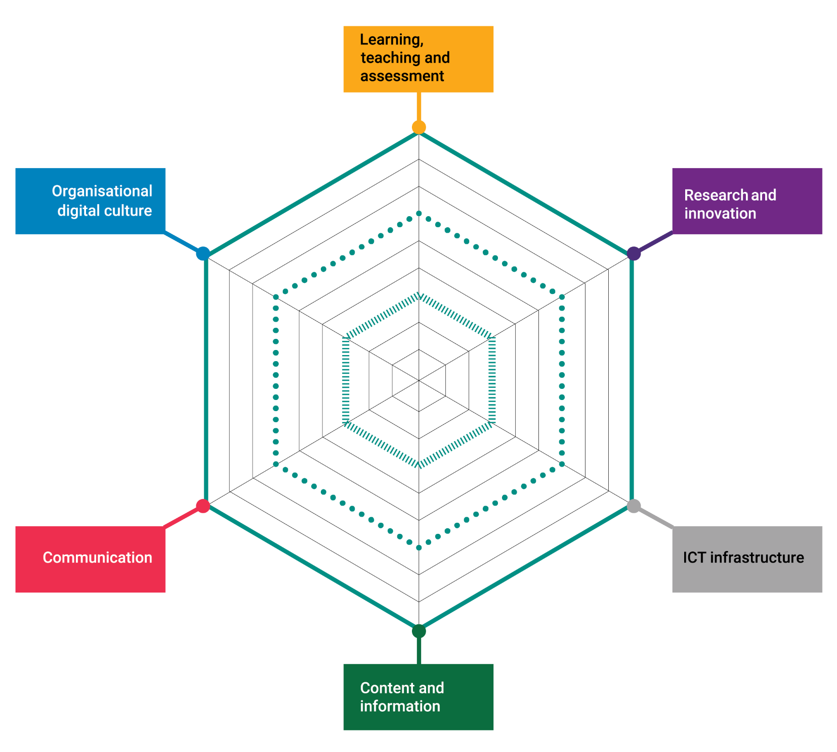
Radar diagram

Use the template to draw a line estimating your level of maturity in each element. Draw a line a different colour to highlight where you would like to be. The coloured lines on the radar chart indicate our different levels of maturity.

