Discovery tool data visualisation reports guide
Updated February 2024 to reflect changes made to the discovery tool in February 2024.

This feature is only available to subscribing organisations.

Contents
Who can view your institutional data visualisations?
Accessing your institutional level data
Welcome page
Summary page
Number of responses by question set
Number of question sets (by dept and subject)
Overview pages (staff and student)
Timeline of surveys started and completion visuals
Confidence level scores
Sector comparison
Detail pages (staff and student)
Responses heatmap
Response options breakdown
Group comparison page
Important notes
Report update frequency
The date range
Filtering
What does 'by department' and 'by subject discipline' mean?
The ‘i’ icon
Logging out
Downloading your data
Exporting to XLS
Making use of your data
Example Summary, Overview and Detail data reports
Example welcome page
Example summary report
Example results overview page
Example results detail page
Example response options breakdown per question visualisation

Who can view your institutional data visualisations?
Only staff who have been assigned permission to view your data visualisations will be able to see the ‘Data’ icon that allows access to this feature. If you need to know who these individuals are, please check with your institutional lead.

Accessing your institutional level data
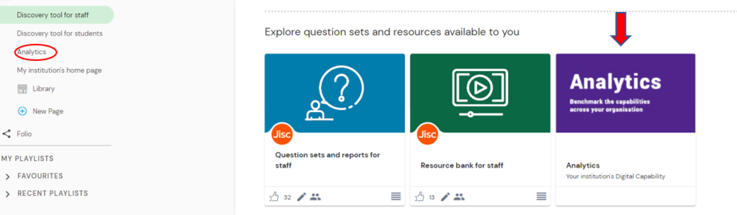
- Log into the discovery tool (https://jisc.potential.ly/signin) and click on the ‘Data’ icon in the menu on your dashboard. (Circled in red opposite)
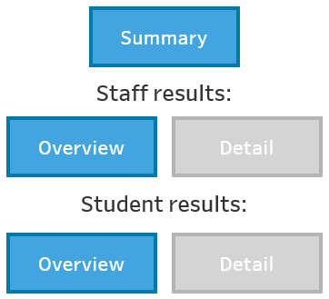
- Enter your data password* on the ‘Welcome’ page in the ‘Enter password’ box and press your enter/return key. This will then show your organisation name below the password box. If this does not happen, you will not be able to see your report.
- Once you have done this, you will be able to access your various data reports by selecting the appropriate buttons or tabs across the top.
  - Overall summary
  - Staff results: overview and detail
  - Student results: overview and detail
More detail on what you can expect in each of these reports can be found in this guide below.
* This password will have been sent to you separately and is unique to your institution. Please contact help@jisc.ac.uk with BDC in the title of the email if you have institutional permissions and do not have this password.

Welcome page
Take a look at an example welcome page.
This is the page that you will see when you first click on the data icon in the discovery tool. This is where you enter your organisation data visualisation code and from here you can use the large buttons to go to the page you want to view. Alternatively you can use the tabs at the top of the page. At the bottom of this page you will see the ‘Last updated’ date for the data visualisation data (for more information on this, see Report update frequency).

Summary page
Take a look at an example summary page.
The summary page provides information on all question sets started in the discovery tool by both staff and students, along with the number of surveys done and in progress. It can be filtered by role (staff or student) and date range. It includes a timeline of surveys started and a breakdown of these by department or subject.

Number of responses by question set
This shows how many:
- total number of users that have completed question sets (top line of table below)
- question sets have been completed: ‘Done’
- question sets have been started but not completed: ‘In Progress’

The ‘All question sets’ figure provides the total number of staff or students who have participated in the discovery tool for the date range selected. This number is likely to be smaller than the total number of question sets completed as staff are likely to have completed more than one question set (eg a number of staff may have completed both the ‘Overall digital capabilities’ question set and a specialist question set such as the specialist ‘Teaching in HE (or FE)’ question set).
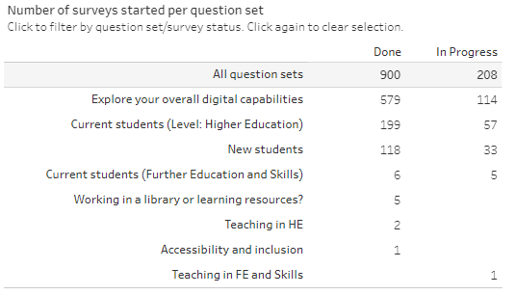

Number of question sets (by dept and subject)
This provides the number of staff or student completions per department (for staff) or subject discipline (for staff and students), depending on the filter applied.
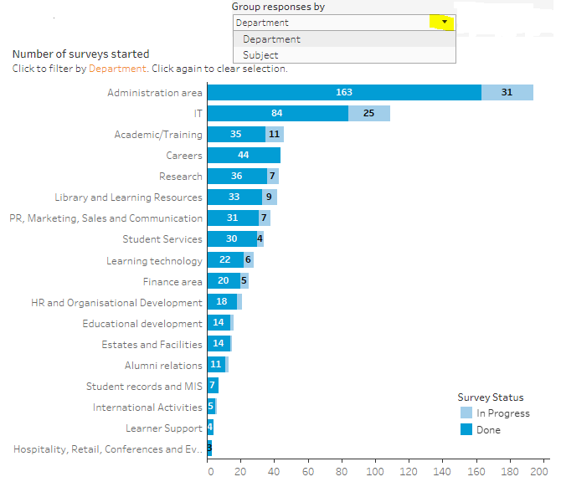
Example above taken from the staff overview report

Overview pages (staff and student)
Take a look at an example results overview page.
In addition to the number of question sets completed, the staff and student overview pages includes
- a timeline of surveys started (done and in progress)
- an in progress/done visual
- a breakdown by results visual
- a sector comparison visual
All of the bulleted features above can be filtered by date, question set, department, subject and level of study (students only). You can also remove you graphs from your view by clicking the ‘X’ icon in the top right hand corner. The charts can be added back to your view by clicking the triple bar icon on the left of the display.

Timeline of surveys started and completion visuals
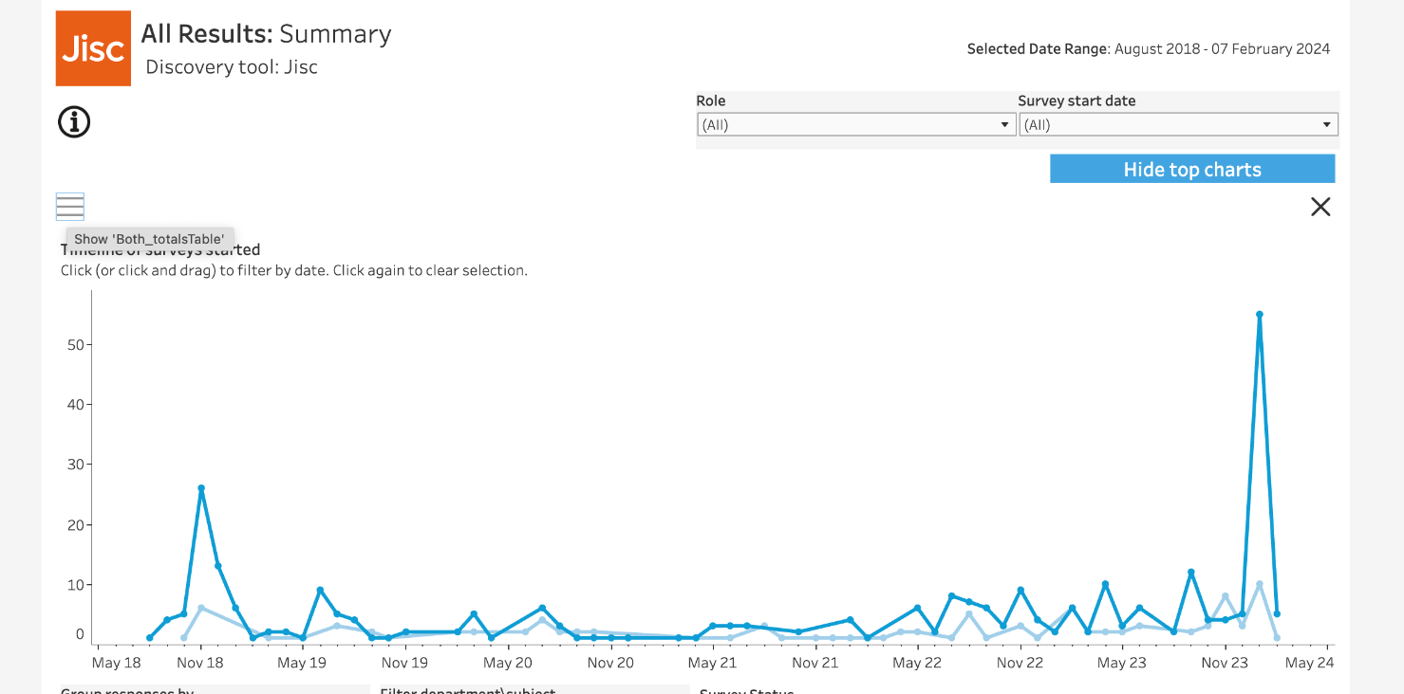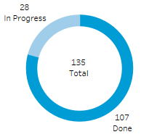

Confidence level scores
You can hover over the percentages on the confidence level breakdown visualisation to find out how many staff/students that they represent and you can also change the view to net confidence score instead (which is calculated by subtracting the proportion of developing users from the proportion of proficient users).
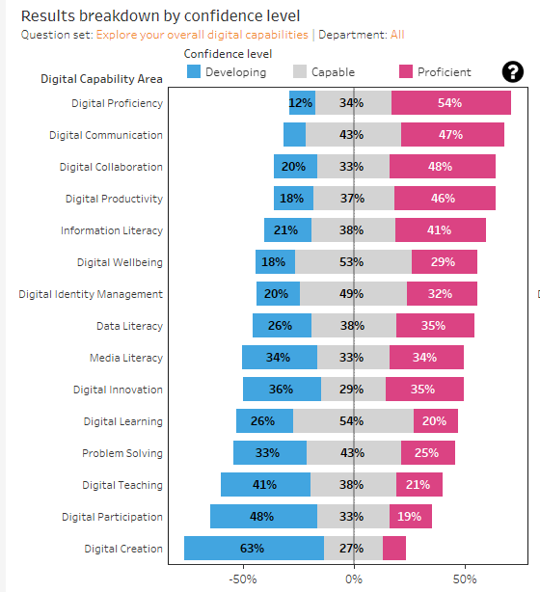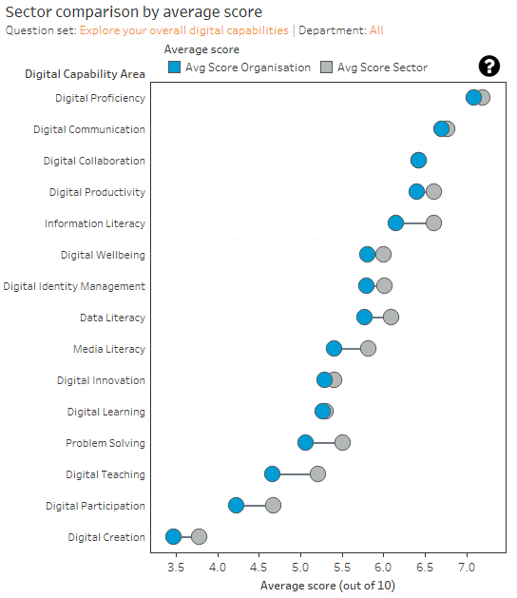

Sector comparison
The sector comparison visualisation compares the average score for each digital capability area for your organisation with the sector average for that area. You can filter this by department/subject heading.
The blue dot represents the average score for your organisation and the grey dot the sector average. If the blue dot is to the right of the grey dot this means that your organisation has scored higher than average in that area. If the blue dot is to the left of the grey dot, your organisation has scored lower than average than the sector in that area. You can hover over individual dots to see the difference in score for each area.

Detail pages (staff and student)
Take a look at an example results detail page.
In the detail page, both the response heatmap and the response options breakdown can be filtered by question set, date, subject area, department (staff only) and study level (student only). If you need to present this information you have the option to the right hand side to anonymise the data and exclude certain departments that you would like to focus on (see chart at the end of this guide).

Responses heatmap
The colours used in the heatmap are used to represent the average user score per digital capability area and department or subject area. A darker colour indicates a higher average score in that area, while a paler colour indicates a lower average score.
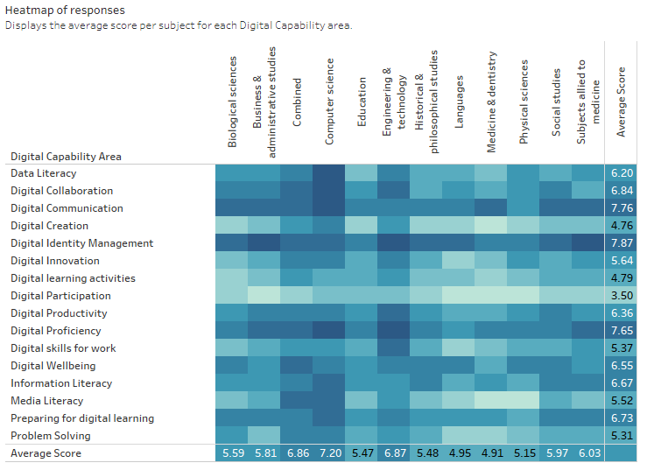

If you have tailored your institutional subject headings when you subscribed to the BDC service these will be reflected in the horizontal data text in the heat map above.

Response options breakdown
By clicking on an individual heatmap square, you can see the responses breakdown for each question - this can be useful to help understand the confidence scores for these areas. To come out of an individual response options view, click on the same heatmap square again.

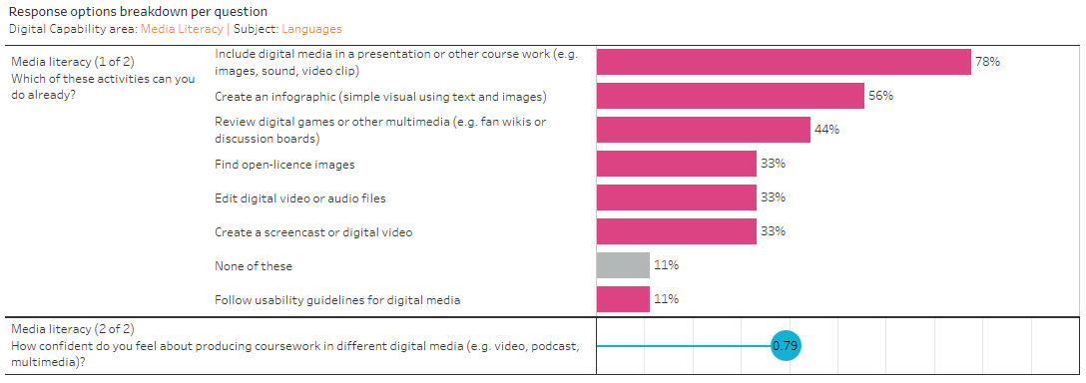

Group comparison page
Please note that this feature is only available to organisations that have signed up to use the tool as a group. It is currently in beta and the following information is for organisations working with us to test this feature. Most people will see no data on this page.

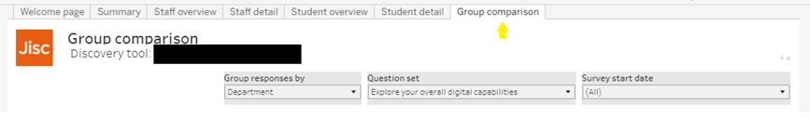

Enter your group password to access group level data, as described earlier in this document.
(If you entered your organisational password to access organisation level data, this page will not be populated with any data. You will need to sign in again using the group password issued to you). The summary, overview and detail pages described above will now be populated with the combined data for all organisations within your comparison group. The group comparison tab (shown below) will be populated with comparison data.

The example below shows the comparison data for a group of three organisations. Each colour block represents a different organisation within the group (names hidden for data confidentiality).
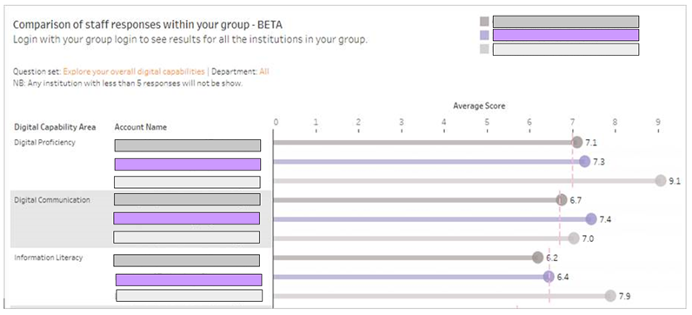
If you would like to visit your own organisation level visualisations, you will need to log out and log in again using your organisational password.

Important notes

Report update frequency
Your institutional data visualisation reports are updated daily. Please note that the ‘Date range selected’ in your overview and detail pages will show the last date a member of your staff or student started a question set.

The date range
The Selected Date Range is important to note as this shows the date range of the data that the report you are looking at is based on. The end date (in this example, 9th January) will be the last date a member of staff or student started a question set in the discovery tool in your organisation.
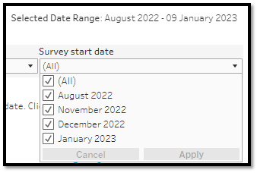
You can check the last time the data visualisations were updated by checking the date shown at the end of the ‘Welcome page’.
The Selected Date Range usually defaults to ‘All’, but you can change this by clicking on the down arrow at the end of the box and then selecting ‘All’ or the range of dates that you want the data visualisation to show you and then clicking on the ‘Apply’ button at the end. You may have to click off the list (by clicking on a different part of the data visualisation page you are on) in order to hide the options once you have clicked on ‘Apply’.
See also Report update frequency.

Filtering
Depending on the view you are looking at, your data visualisation report can be filtered by a number of options, including:

- Date range
- Question set
- Department
- Subject
- Role
- Digital capability area
- Level of study (student data only)
The filters can either be applied using the drop down boxes at the top of pages (the example below is from the staff overview page) or by clicking on relevant headings to filter that way.

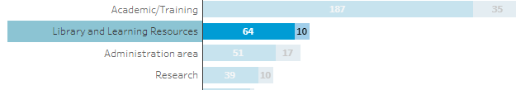
To remove filters applied this way (by clicking on relevant headings) you need to click on the same heading again to clear the filter.

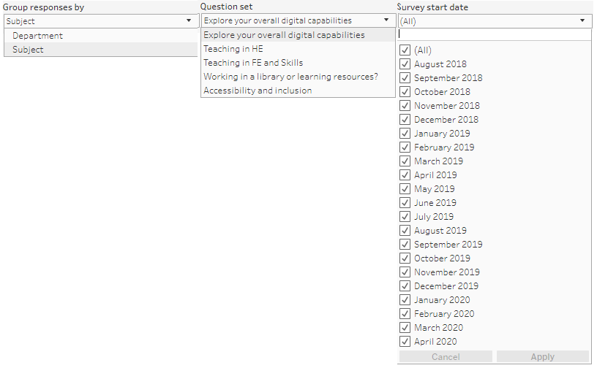

What does 'by department' and 'by subject discipline' mean?
The data for this information is based on the fixed drop-down options that your staff or students selected when they signed up to the discovery tool. For full details on what these are see:
- discovery tool department list (see page 5)
- subject discipline lists:
  - staff (see pages 5-13)
  - students (see pages 5-6)

The ‘i’ icon
The ‘i’ icon appears in a number of places in the data visualisation pages. Where it appears, you will be able to find out overview information for the data or visualisation that it is next to by clicking on it. To remove the information, click on the X that appears at the top of the information box.

Logging out
To ‘log out’ of your data visualisation simply leave the data page by clicking on the home image in the breadcrumb trail at the top or by selecting any of the other icons in the left hand dashboard menu.
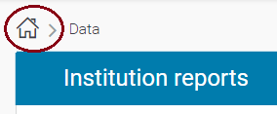

Downloading your data
Your data can be downloaded in a number of different formats, including:
- PDF
- Image (PNG file)
- PowerPoint
- XLS (Excel spreadsheet) (only available on overview and detail pages)

The first 3 options will save the view that you can see on your screen (so if you have filtered the content, this is the view that will be saved). To download your data view as PDF, image or PowerPoint, click on the ‘Download’ icon in the top right of your screen and then click on the format that you want to download the data in. Please note that you will see another two format options available from this download button including ‘crosstab’ and ‘data’. The data you will get from this ‘data’ option will be very limited compared to the xls download option, so we don’t recommend using this. Additionally, we are not able to provide support if you decide to use the crosstab function.

Exporting to XLS
This option downloads all the raw (anonymous) data associated with the data visualisation page you are looking at (if you have filtered your view, this will not filter the data downloaded as a CSV file). There are two raw data reports that you can download:
- Staff and student overview information. This is available from the overview pages and pages includes question set ‘in progress’ and ‘done’ data, along with associated subject and department headings, user role (staff or student) and confidence levels.
- Staff and student question response detail. This is available from the staff and student ‘detail’ pages and provides the response data from your staff or students in detail (e.g. the actual responses given for the grid questions and confidence slider scores.
The same data is generated regardless of whether you are in the staff or student view for either of these reports.
To access this function, click on the downward arrow icon that you will see in the top left of your screen. This will open an ‘Export to XLS’ box. Click on the green ‘Download’ button to start your download. Once the download has completed, you will need to click on the X in the right of the ‘Export to XLS’ box in order to remove it. Please note that the Jisc Building digital capability team is not currently able to provide support and guidance on how to use the raw data.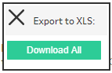

Please note, if this box (see below) appears when you try and download your XLS report, please click on ‘Allow’.
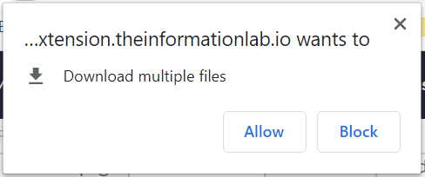

Making use of your data
Guidance was developed as part of the pilot project for the discovery tool. We are planning to update this guidance on how to make use of your data, but in the meantime the information created for the pilot organisations is still a very useful starting point on how you might make use of this data in your organisation. See this article.

Note: You should not rely on these data visualisations as a definitive source of information about staff training needs.

Example Summary, Overview and Detail data reports
Examples of Summary, Overview and Detail reports can be seen on the following pages.

Example welcome page
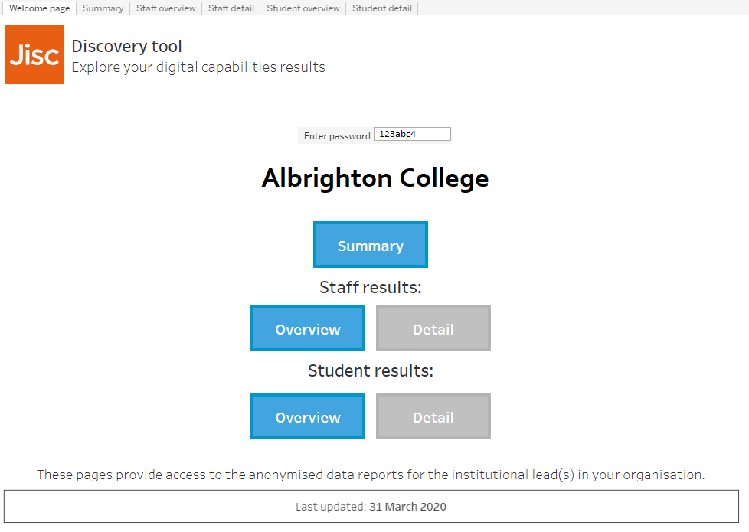

Example summary report
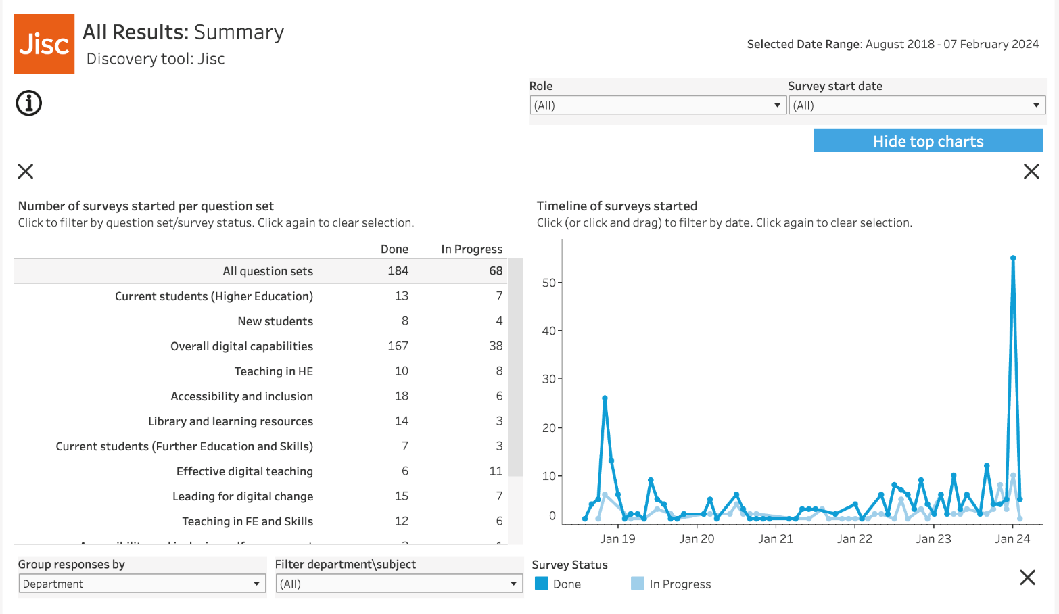

Example results overview page
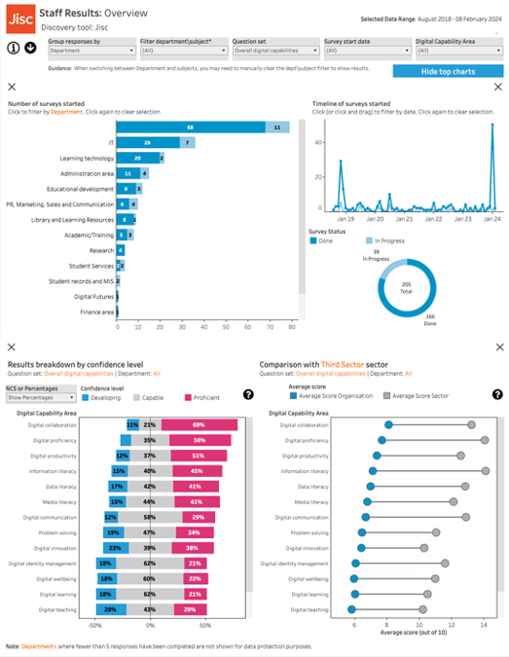

Example results detail page
This example is based on a student detail page. 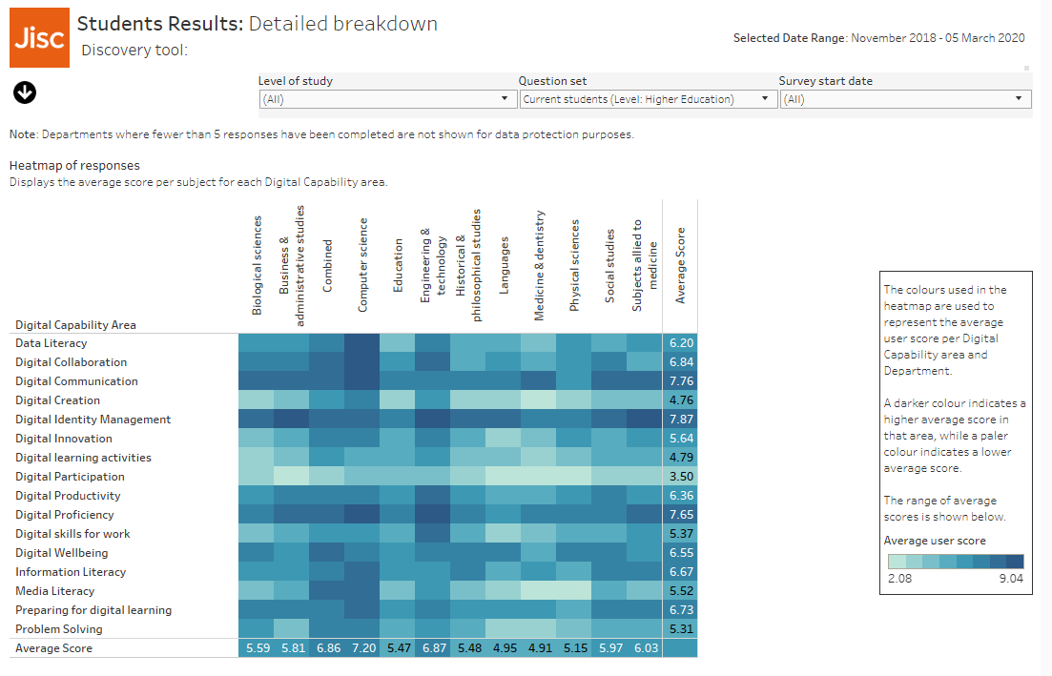

This example demonstrates the anonymised results

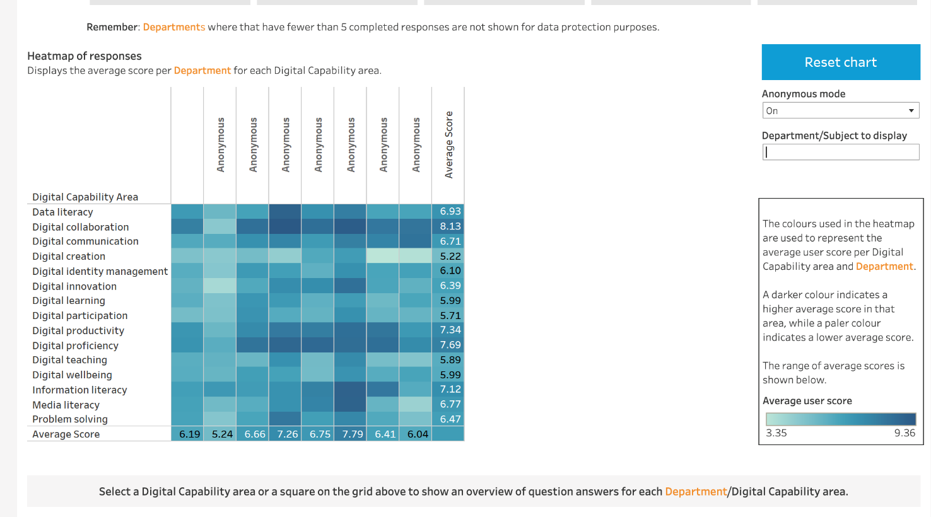

Example response options breakdown per question visualisation
